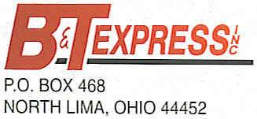

INTERNSHIPS and FULL-TIME OPPORTUNITY
SKILLS USA…$1000 SIGN ON BONUS…

Congratulations on your participation in SkillsUSA. You should be very proud of your accomplishments. Your dedication and hard work are paying off and are paving the way to a great future. At B&T Express, Inc., we look for unique candidates just like you who are dedicated and committed to their futures.

B&T Express would like to offer you a paid internship opportunity or full-time diesel mechanic position with a $1000 sign-on bonus!!!

B&T Express, Inc. is a fourth-generation, family-owned freight and logistics company. We are unique in the way we operate. Our most important resource is our people.

Reasons to Choose B&T Express:

- Family-Owned/Operated since 1928
- Safety-First Mindset
- Ohio, Alabama, and TN locations
- Newest EQUIPMENT
- Uniforms Provided
- RELOCATION Assistance
- TUTION Assistance
- Assistance with TOOLS
- GREAT PAY
- Various BENEFITS
- SIGN-ON BONUS
- ASE CERTIFICATIONS

Like you, we are dedicated to excellence. I would be very interested in talking with you further about the Diesel Mechanic positions at B&T Express, Inc. Please contact me at 330-406-6820 or cdelahunty@btxpinc.com.

Again, congratulations! You are a very unique and talented individual.

Sincerely,

Chris

Christine M. Delahunty
Company Recruiter
330-406-6820
cdelahunty@btxpinc.com
www.btxpinc.com

